**TOGETHER TO GET BETTER**

Bengaluru, Karnataka, India

AN INTERNSHIP REPORT

ON

“Custom Resume Generator”

#### Bachelor of Engineering

#### In

#### Computer Science and Engineering

#### 

#### Submitted by: Naveen S Math(3BR19CS097)

#### 

#### 

#### 

**BALLARI INSTITUTE OF TECHNOLOGY AND MANAGEMENT**

#### 2021

***ABOUT THE COMPANY*** `

Bionic Engineers provide engineering consultant services. It's not just another engineering consultant, it offers top notch services to clients and employees .

The company's latest projects include Soldier health monitoring system, Theater piracy protecting system and Tens machine a biomedical project.

Bionic engineers offer all kinds of IEEE standard academic project services for ECE and CSE domain students. Some of the services are given below:

* 3D printing

*Vinyl printing

*Internships and workshops

***TABLE OF CONTENTS***

|  |  |  |
| --- | --- | --- |
| Sl No | Contents | Page no |
| 1 | Overview of the Project | 4 |
| 2 | Requirement of Project for Use | 5 |
| 3 | Tools Required | 6 |
| 4 | Implementation | 7 |
| 5 | Snapshots | 8-11 |
| 6 | Bibliography | 12 |
| 7 | About the Team | 13 |

**Overview of the Project**

**Project Name**: *Custom Resume Generator*

**Team Members**: **1. Naveen S Math**

**2. Akash B**

**3. Jasmine Karam**

For a long time, building a resume has been one hell of a job, the process of combining all the data that’s required to be put up on the resume and deciding the right design to go has become a nightmare for a lot of youngsters who wish to get things done in no/very less time, and have no patience to wait in order to attain perfection in building/achieving whatever they desire to, by Introducing a custom resume builder that targets the kind of crowd that is mentioned above, we wish to provide a neat and clean resume specifically targeting the generation that thrives simplicity and elegance.

The idea of our Custom resume generator is to help students to get their resume in hand just by filling up a simple form where important credentials need to be filled.

*The resume is downloadable in PDF format. Also, the user can log in again to access the previous resume that he/she has made

*The resume is of Standard Format as stated by most of the Engineering

**Requirement of Project**

The website is made easy to use and is be user-friendly. It is compatible with mobile phones and other devices. Also, the data of the user is completely secured and he/she has to make an account and set their password to access their Resumes at any point in time. As stated above, the Resume is downloadable in PDF format which is quite a unique feature that saves a lot of time and energy.

Structural and Conceptual Planning:

● Conversion of current web page content into PDF format.

● Encrypting passwords for user privacy.

● Making a website compatible to use on other devices.

***Tools required***

1. PHP server-XAMPP, WAMP, etc.

2. MySQL Database – For managing data entered by the user.

3. Editor –Visual Studio Code.

4. Front End Requirements – HTML, CSS, Javascript, BS.

***Basic tools you will need***

For good performance, you will at least need a Pentium 200-MHz computer with a minimum of 64 MB of RAM

You will also need the following software −

● Linux 7.1 or Windows xp/7/8/10 operating system

● Text editor (VS code recommended)

**IMPLEMENTATION**

[**index.html**](index.html)

[**contact.html**](contact.html)

**resume.html**

[**config.php**](config.php)

[**login.php**](login.php)

[**logout.php**](logout.php)

[**register.php**](register.php)

[**script.js**](script.js)

[**style.css**](style.css)

**\*NOTE : As copying the code into the doc would make the file too large I added the links to the source code here**

**Screenshots**

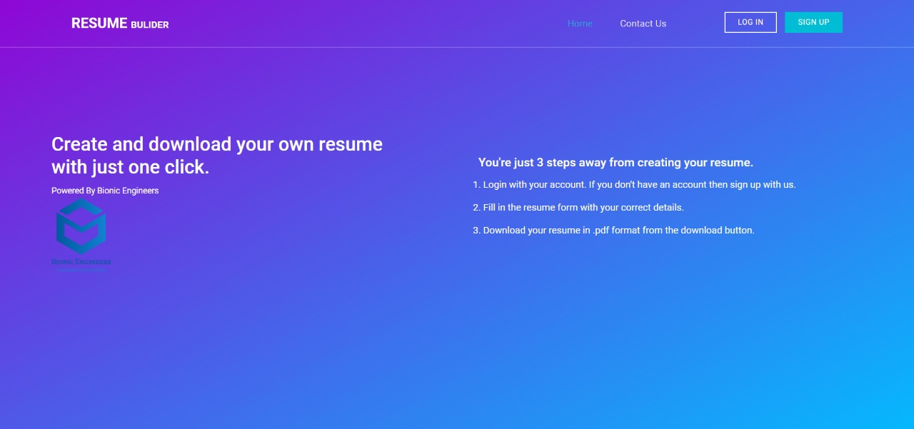

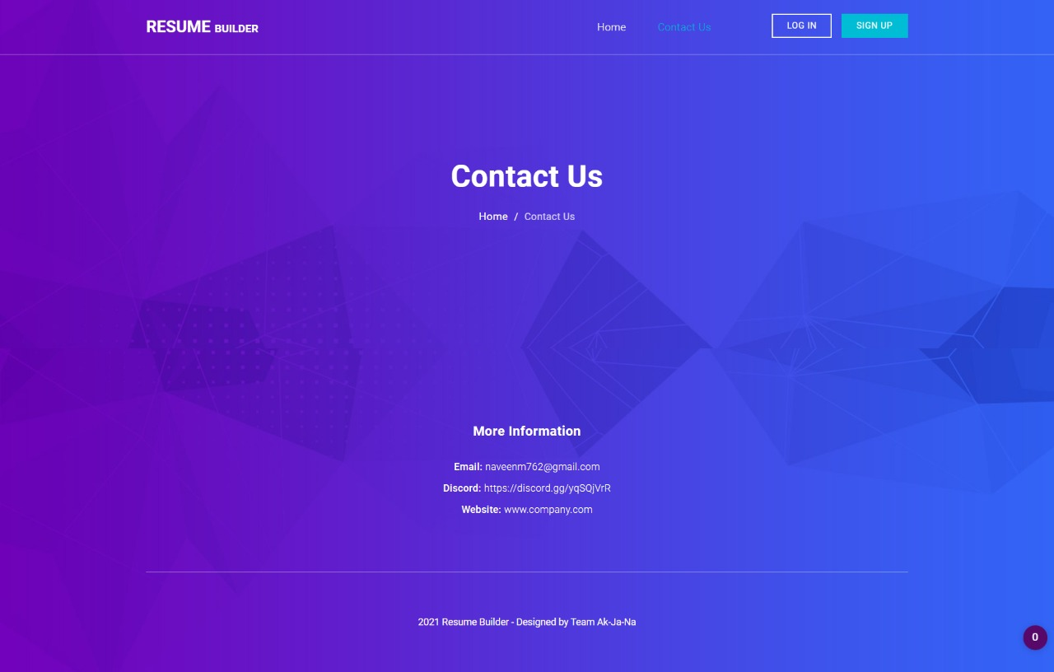

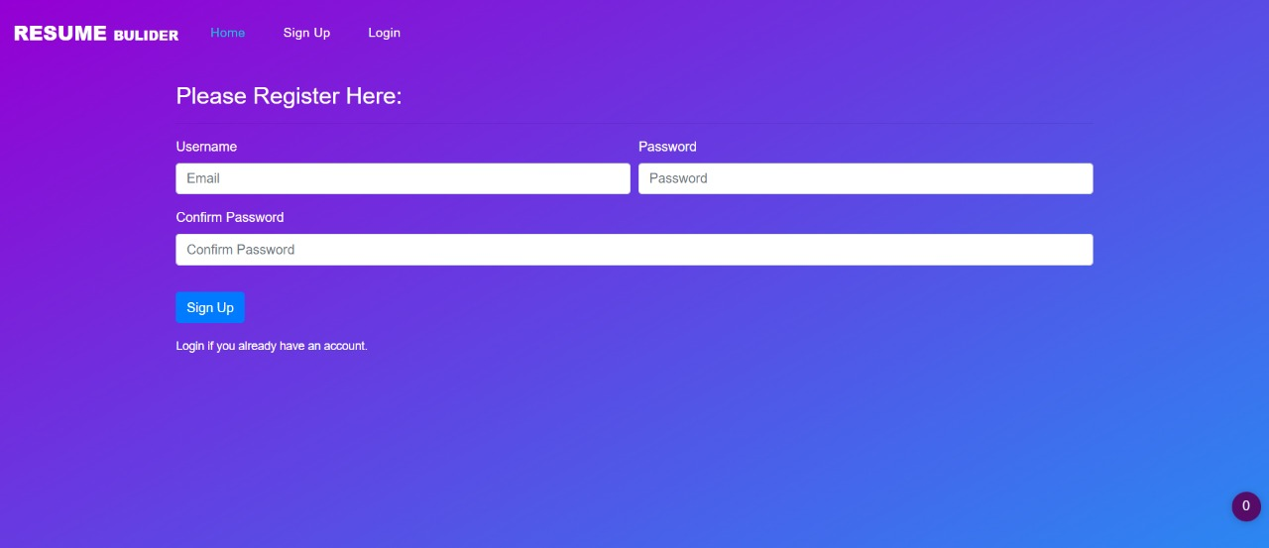

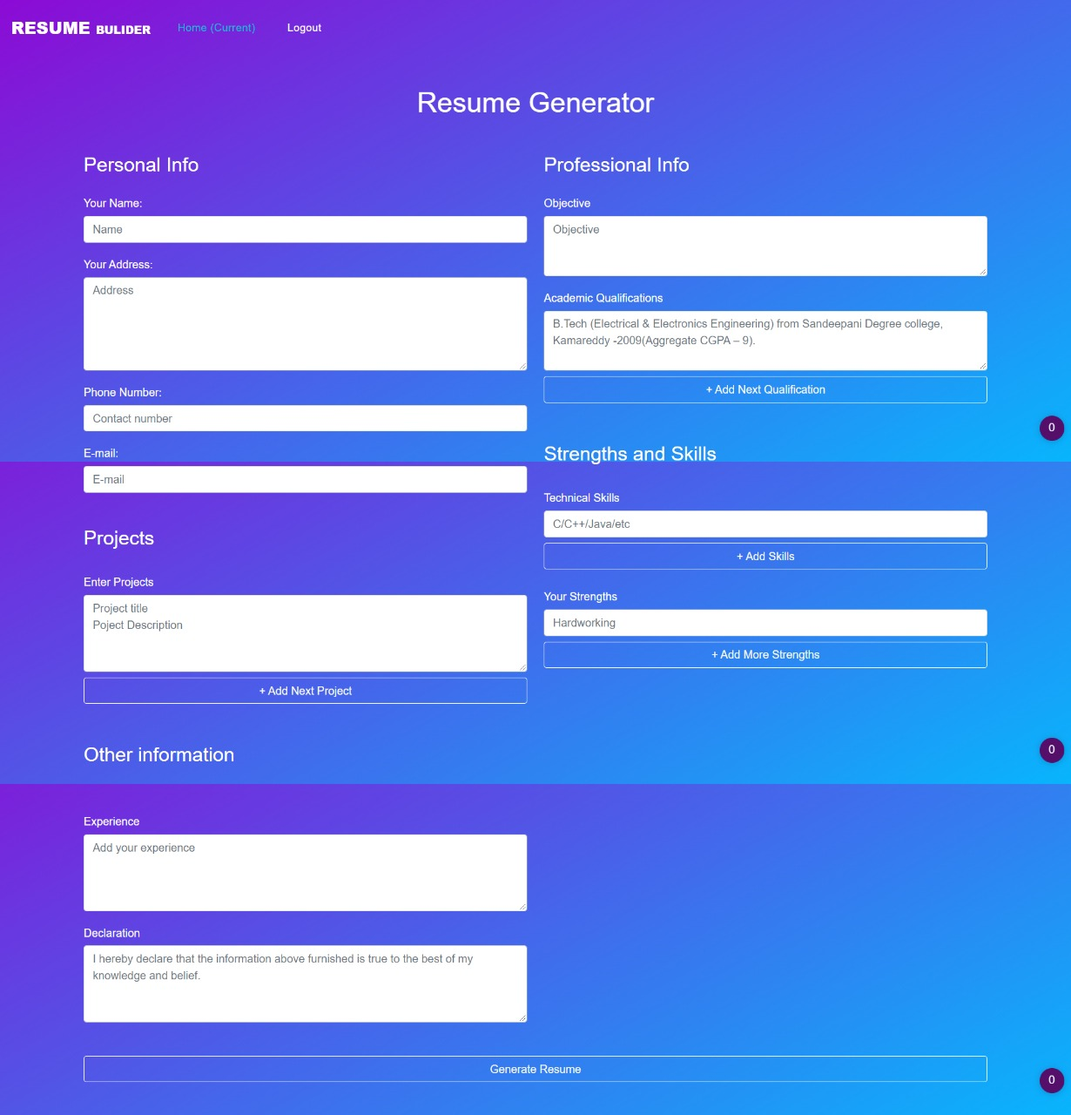

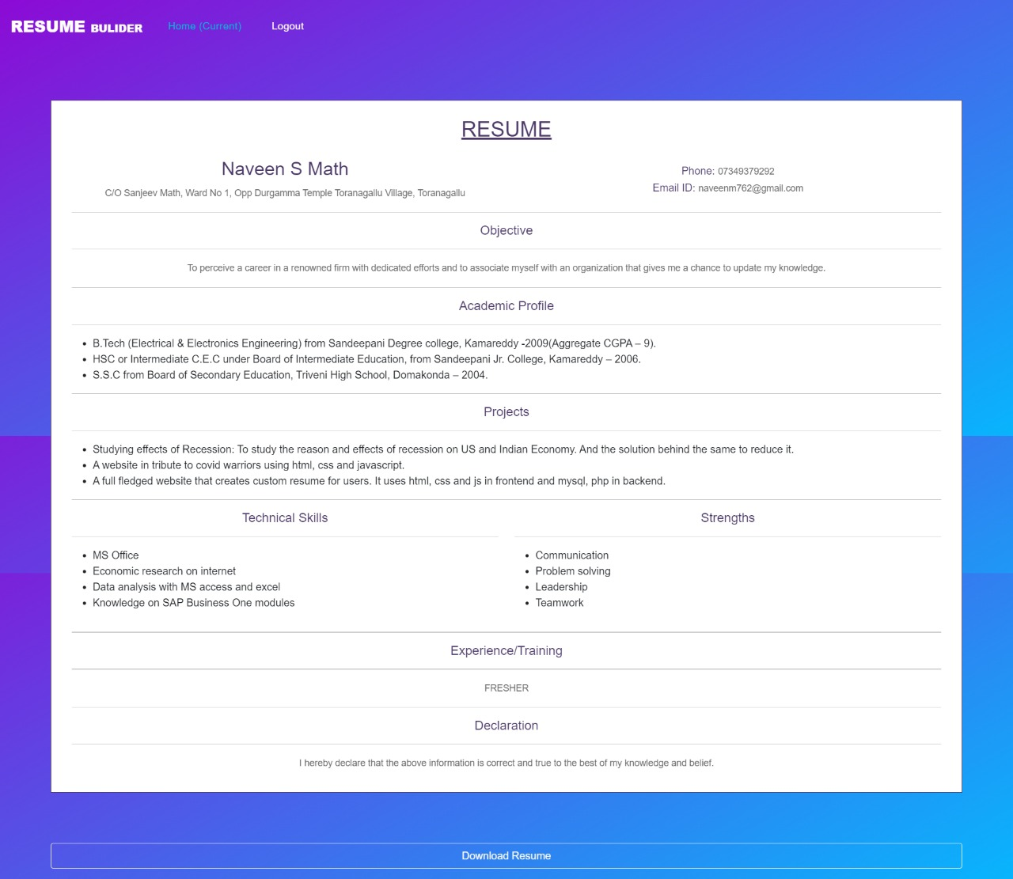

**Bibliography**

* W3geeks
* Stackoverflow
* Mdn Mozilla
* Fontawesome
* Github

**About the Team**

* **NAVEEN S MATH** (Code lead)
* **AKASH B** (Team Leader) Junior Web Developer
* **JASMINE KARAM**